Dear all,

I hope you are all doing fine and not affected by covid 19 too much.

Sorry the manuscript is taking such a long time. I’m very busy with my current work and I also faced a few problems regarding potential biases in carcass detection. I’d like to have your opinion.

In short, I think that the spatio-temporal roadkill patterns that we detected and interpreted as biological effects could potentially result mostly from a bias in observation effort, as the data seem to suggest that carcasses are more likely to be detected during the wet season and in the short-grass plains. As you may recall, in the manuscript we were using the occurrence (or not) of monitoring sessions (observation at clan communal dens) as an indicator of researcher presence in the Serengeti, and therefore, in a way, of observation effort. We showed in the manuscript that such effort did not vary across seasons. In other terms, if we would only include in the study hyena carcasses found and handled by members of the hyena project, we could be fairly confident that there is no bias in observation effort. However, I wonder if there is such a bias when considering the additional carcasses that were found and handled by other persons, and which constitute a large proportion of the overall dataset.

In the rest of this document, I’ll use the word “season” loosely to refer to the periods during which the migratory wildebeest herds are in the short-grass plains (wet season), in the North and in the Masai Maara Reserve (dry season) or in transit between these general locations (transit).

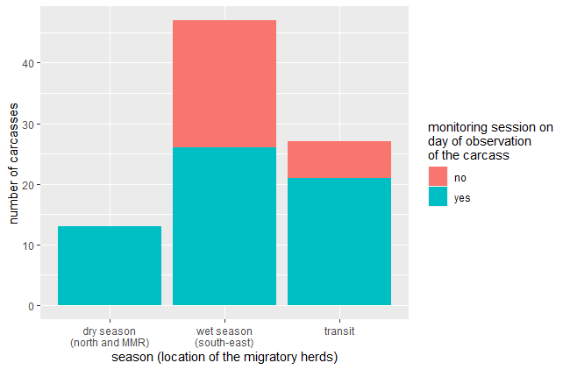In order to see whether carcasses detected by other persons than members of the hyena project did not vary across seasons, I checked the number of carcasses that were found on a day without monitoring session, by season (Figure 1). Do not pay attention to the absolute numbers, as the seasons do not have the same length, we’re interested in proportions here. As you can see, in the dry season, this proportion is 0/13, whereas in the wet season, it’s 21/47.

**Figure 1. counts of carcasses found on a day with or without a monitoring session.**

It’s not surprising that carcasses are found on days without monitoring sessions. EWhat I found surprising was the striking difference between the proportion of carcasses found on a day without monitoring session in the wet VS the dry season. So I wondered whether the excess of carcasses found during the wet season (and reciprocally the deficit of carcasses found during the dry season), after controlling for season length, could be due to biases in observation effort and thus in detection probability. **Specifically, are there more researchers (who are *not* members of the hyena project) in the Serengeti during the wet season, so that a larger proportion of the carcasses are reported?**

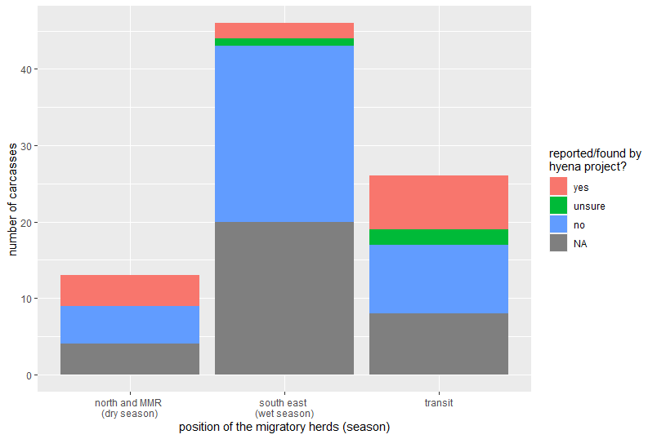A better (but still flawed) indicator to reveal variations in observation effort would be the affiliation of the person who reported i.e. detected the carcass i.e. hyena project or not (Figure 2). As you see there are a lot of carcasses for which we don’t know who reported it (NA), ~~as well as a few carcasses for which I’m unsure whether the person belongs to the hyena project~~. It’s not very striking but it seems that ~~again~~, the proportion of carcasses found by the hyena project (in pink) is lower during the wet season than it is during the dry season, **potentially indicating that there are more observers who are not members of the hyena project and therefore a higher chance of detecting carcasses in the wet season.**

**Figure 2. Affiliation of the person who found or reported the carcass, by season (i.e. does this person belongs to the hyena project?)**

I then checked the proportion of carcasses handled/examined by the hyena project i.e. when carcasses were dissected by members of the project (Figure 3). Again, it’s far from being a perfect indicator, since carcasses can be found by rangers, tourists, staff, vets or other scientists and nonetheless be examined by the hyena project. Still, the same pattern appears.

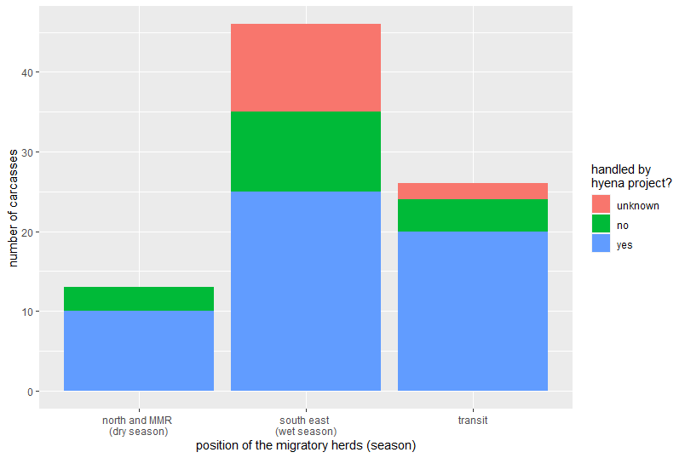

**Figure 3. Affiliation of the person who handled/examined the carcass by season (i.e. does this person belongs to the hyena project?)**

To further get an idea of whether the patterns we observe in the manuscript could be due to this putative bias, I plotted the latitude and longitude of the carcasses by season, and by affiliation of the person who examined each carcass (Figure 4 below). I looked at that because in the manuscript, we show that during the wet season, the carcasses are found further to the south and to the east than during the dry season, supposedly because during the wet season, wildebeest are in the south-east. As you can see, during the wet season, the carcasses that were not handled by the hyena project were further south and further east than the carcasses handled by the hyena project. It means that these carcasses could be driving the observed patterns to some extent.

These findings made me re-consider how robust our findings are. I was always conscious that biases could affect our results, but I used to consider that their effect would be marginal.

**Figure 4. Latitude (top) and longitude (bottom) of the carcasses by season and by affiliation of the person who handled/examined the carcass**

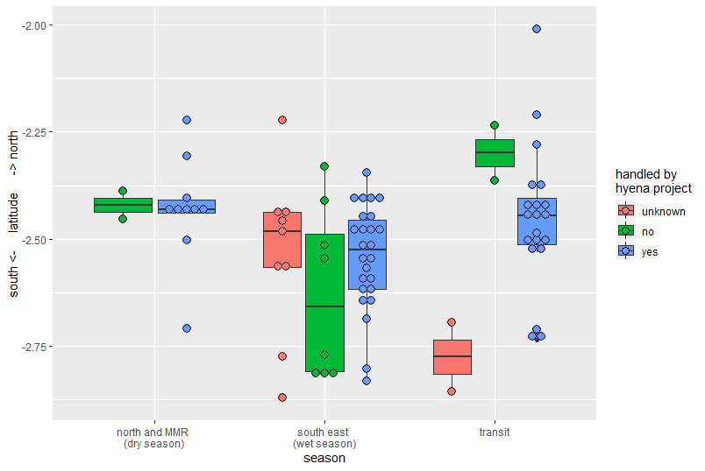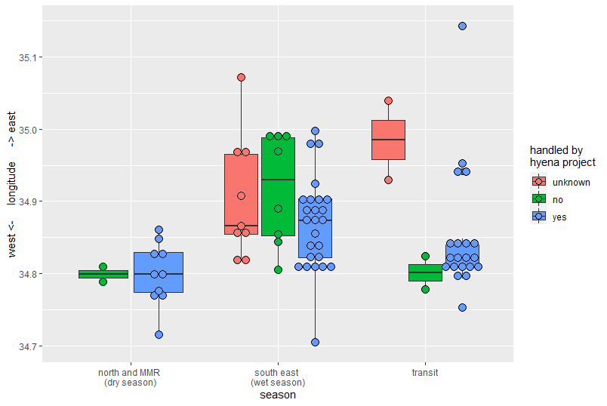

One reassuring thing is that there actually are probably fewer researchers in the Serengeti during the wet season notably because the roads are bad at that time of the year. Since many of the carcasses (roughly 20) were found/reported by scientists, knowing that there are fewer scientists during the wet season is reassuring.

Similarly, according to this book chapter (Climate Change Threatens Major Tourist Attractions and Tourism in Serengeti National Park, Tanzania), there are fewer tourists during the wet season (which could mean a lower detectability of carcasses). Again, it’s reassuring that the pattern of tourist number is the opposite of our pattern of carcass number. Marion and Heribert, did you also observe that there are less tourists during the wet season?

Moreover, I ran the analyses after removing the carcasses that were not examined by the hyena project (green and pink in figure 3), and the direction of the effects and patterns did not change compared to when using the full dataset, although their intensity did.

Finally, I ran the analyses after removing the carcasses that were found on a day during which no monitoring session (pink in figure 1), and again, the direction of the effects and patterns did not change.

What do you think of all this?

Some questions remain:

* According to Sarah and Sonja, if a carcass was found on a given day, it means that in most cases a hyena project member was most likely in the Serengeti, otherwise the carcass would simply not have been reported or found. Is this true for the older carcasses? If it’s true, should we try to find the dates of arrival and departure of members of the hyena project since the 1990’?
* Alternatively, it may be relevant to keep using the proportion of days with a monitoring session for each season as an indicator of constant “research effort”. If we consider that the proportion of days with a monitoring session is a good proxy of the number of days spent in the Serengeti (e.g. for every 5 monitoring session, 6 days were spent in the Serengeti by ≥1 hyena project member), then the proportion of days with a monitoring session could be a good indicator or “research effort”.